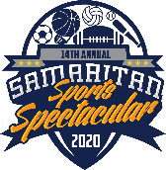

INTENT TO SPONSOR

Company Name:
Contact Name:
Business Address:
City: State: Zip:
Phone #:
Email Address:

Yes, we will sponsor the Sports Spectacular 2020 Audible at the level of:
VIP: ($5,000) This level will help Samaritan begin the counseling process in changing the lives of 125 people.

CHAMPIONSHIP: ($3,000) This level will provide for 75 family sessions reducing separation, divorce, and domestic violence.

TOUCHDOWN: ($1,000) This level will give 25 sessions of hope for children who have experienced abuse, neglect, and bullying.

FIELD GOAL: ($500) This level will scholarship 8 individuals for grief support, anger management, and behavioral addiction groups.

SAFETY: ($250) This level will scholarship individuals and families who seek treatment through tele-health, tele-psychiatry and Neurofeedback.

To facilitate communication of your sponsorship, we need your commitment by July 1, 2020. Intent to sponsor forms must be returned to assure listing you as a sponsor.

Samaritan Center is 501(c)3, non-profit agency, # 23-7337599. Thank you for your contribution to support the Samaritan Team!

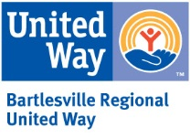

SAMARITAN COUNSELING & GROWTH CENTER
245 SE Madison Boulevard • Bartlesville, Oklahoma 74006 • 918-336-1463
www.samaritanbartlesville.org

